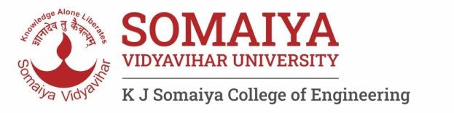Year : 2020-

**Department of Science and Humanities**

Engineering Chemistry Laboratory

List of Experiments (2021- 22)

|  |  |  |
| --- | --- | --- |
| **Sr. No.** | **Name of Experiments and link** | **CO Mapping** |
| 1 | To understand & familiarize with Good Laboratory Practices in Chemistry Laboratory  https://www.youtube.com/watch?v=TADfGsai3Ro | CO 1-5 |
| 2 | To understand the concept of pH indicator and to determine suitable indicator for acid-base titration.  <https://vlab.amrita.edu/?sub=2&brch=193&sim=352&cnt=4> | CO-1 |
| 3 | To determine the hardness of water using EDTA titration.  <https://vlab.amrita.edu/?sub=2&brch=193&sim=1548&cnt=1> | CO-1 |
| 4. | To determine the chemical pollutants in water samples using advanced analytical techniques.  <https://vlab.amrita.edu/?sub=2&brch=193&sim=1548&cnt=1> | CO- 4 |
| 5 | Determine the viscosity average molecular weight of a polymer  <https://vlab.amrita.edu/?sub=2&brch=190&sim=603&cnt=1> | CO-2 |
| 6 | To study the construction and working of compression molding.  http://vlabs.iitb.ac.in/vlabs-dev/labs/mit_bootcamp/polymer_process/experiments/working-of-compression-moulding-mit/index.html | CO-2 |
| 7 | To find out the unknown concentration of the sample and verification of Beer-Lambert's Law  <https://vlab.amrita.edu/?sub=2&brch=190&sim=338&cnt=1> | CO-5 |
| 8 | To determine the available nitrogen in the soil sample by Kjeldahl Method  <https://vlab.amrita.edu/?sub=2&brch=294&sim=1551&cnt=1> | CO-3 |
| 9. | Interpretation of IR spectra | CO-5 |
| 10. | To measure the EMF of a cell and predict the spontaneity of the cell reaction  https://vlab.amrita.edu/?sub=2&brch=190&sim=361&cnt=1 | CO-3 |
| 11 | To determine the pH value of given solutions using pH meter.  http://vlabs.iitb.ac.in/vlabs-dev/labs/nitk_labs/Environmental_Engineering_1/experiments/determination-of-ph-nitk/index.html | CO-5 |
| 12 | To study the catalytic effect of finely divided particle  https://csc-iiith.vlabs.ac.in/exp/catalytic-effects/theory.html | CO-4 |

Dr. Bharati Choudhari

**Lab In-charge- Engineering Chemistry Laboratory**